- How to compile the program

The program was developed in JAVA language using Eclipse 3.5 IDE. To compile and run this program, JDK 6 and Eclipse 3.5 are needed. JDK 6 can be downloaded at http://java.sun.com/javase/downloads/widget/jdk6.jsp and Eclipse 3.5 at http://cloud.eclipsesource.com/R/eclipse-java-galileo-win32.zip .
  - Install JDK 6
Install the java.exe file downloaded and add to the Environment Variable PATH “C:\Sun\SDK\bin” (default)

  - Install Eclipse 3.5
Unzip the eclipse-java-galileo-win32.zip file downloaded from the above address and you will find the executable file ./eclipse/ eclipse.exe. Double click the icon of the executable file, and Eclipse IDE will start.

  - Import the project
Click “File”→”Import”, and choose “Existing Projects into Workspace” under “General” folder. Then click “Next” and select the root directory by clicking “Browse”. Click “Finish” after choosing the root directory of the project.

  - Compile & Run the program
There are two JAVA files in the project, named Pastry.java and PastryUI.java. Pastry.java is the logic part and PastryUI.java is the UI part. To run the program, you can click “Run”→”Run as”→”Java Application” in PastryUI.java.
An executable .jar file PastryUI.jar is also provided. After installing the JRE (Java Running Environment), you can run this file by typing “java –jar PastryUI.jar” at the command line.

- How to use the program

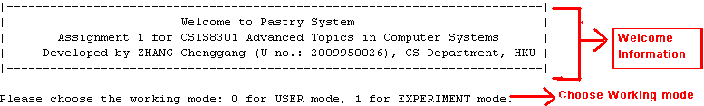


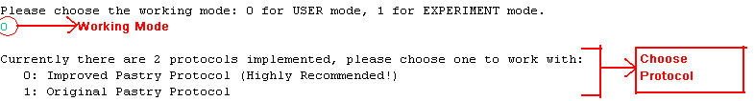

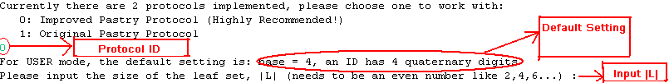

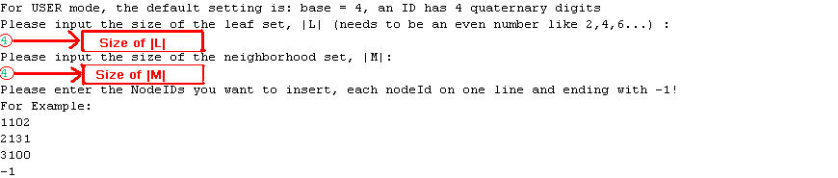

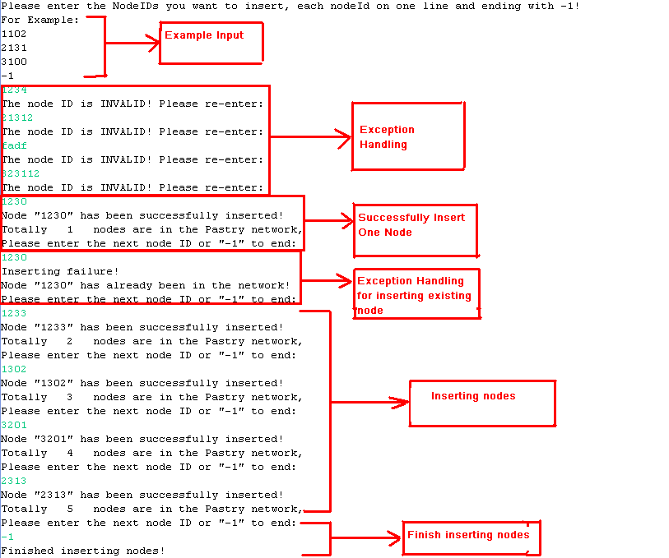

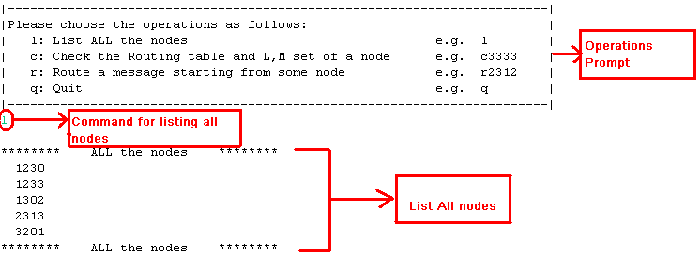
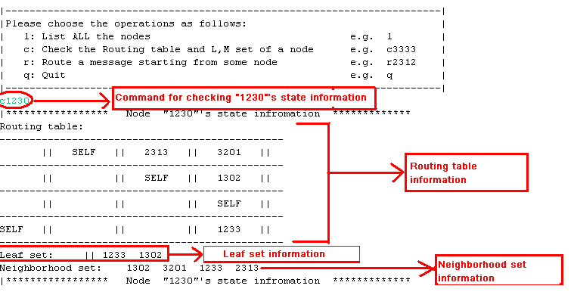

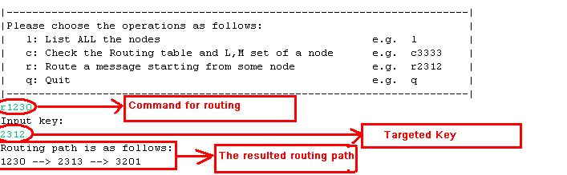

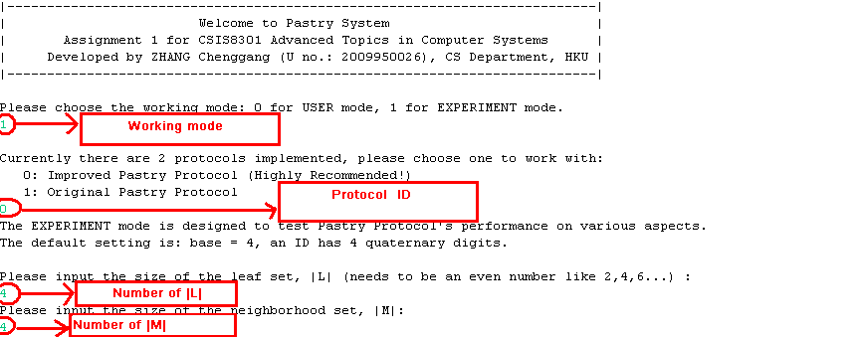

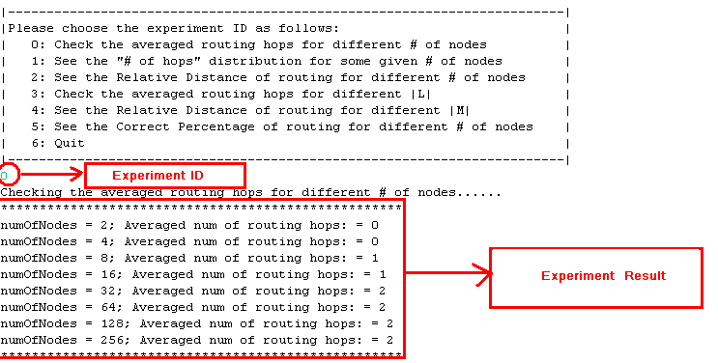

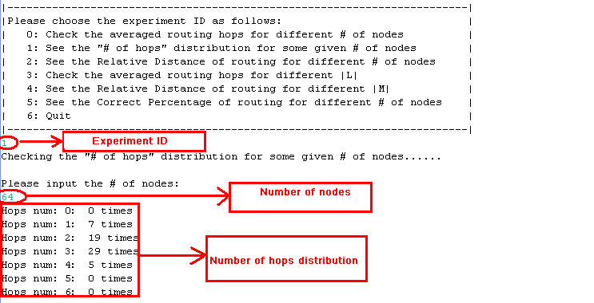

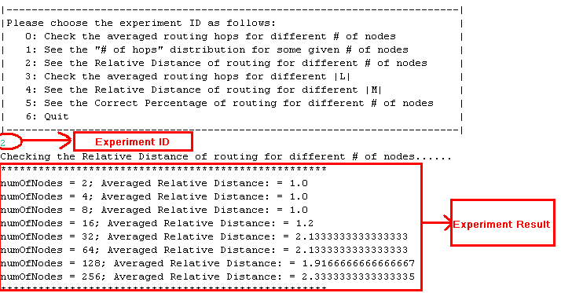

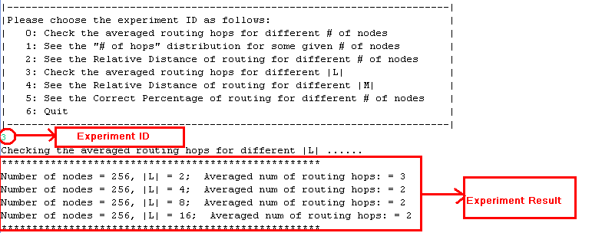

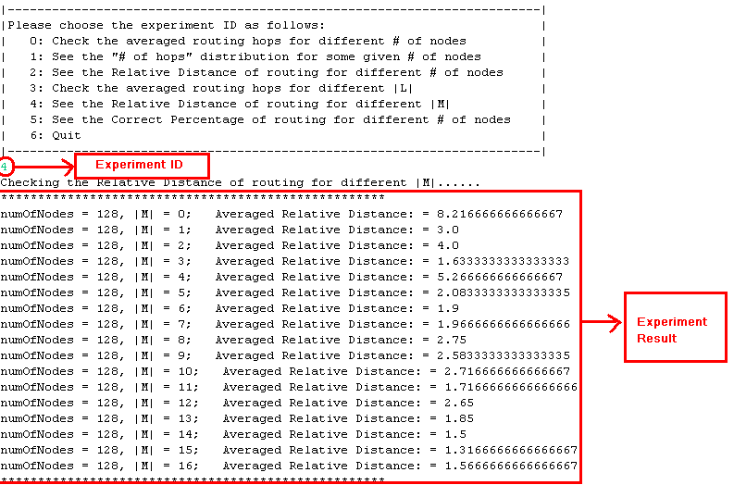

- Special notes
Currently two versions of Pastry protocols have been implemented: the original Pastry protocol and the improved Pastry protocol. The improved Pastry protocol is relatively better tested than the original Pastry protocol, so there may be some bugs in the original Pastry protocol implementation.
The Original Pastry Protocol works as follows when constructing a new node X’s Routing table, Leaf set and Neighborhood set (will be referred to as R table, L set and M set respectively): Define the new node as X, and the physically nearest node in Pastry Network is A. Then A routes the “join” message with X’s ID. Suppose the routing path is A→B→……→Z, and Z is the numerically nearest node to the new node X. To construct the R table, L set and M set, X copies the routing path’s i^{th} node’s i^{th} row to its i^{th} row, copies Z’s L set to its L set, and uses A’s M set as its own M set.
The Improved Pastry Protocol works as follows when constructing a new node X’s Routing table, Leaf set and Neighborhood set (will be referred to as R table, L set and M set respectively): Define the new node as X, and the physically nearest node in Pastry Network is A. Then A routes the “join” message with X’s ID. Suppose the routing path is A→B→……→Z, and Z is the numerically nearest node to the new node X. To construct the R table, L set and M set, instead of just copying the routing path’s i^{th} node’s i^{th} row to its i^{th} row, copying Z’s L set to its L set, and using A’s M set as its own M set, X considers all the nodes along the routing path and uses them as currently known live nodes in the Pastry Network to construct its own R table, L set and M set. (More details can be found in the following methods: constructRTable(),constructLSet() and constructMSet() in the Pastry.java in the source code directory)
Also, two working modes are provided. One is USER mode, which is designed for the user to use and test Pastry. The other is EXPERIMENT mode, which is used for testing the performance of Pastry Protocol.

If you have any questions about the program itself and how to compile and run it, do not hesitate to contact with me. Thank you!
MSN: chenggangschool@hotmail.com
E-mail: cgzhang@cs.hku.hk

